Corinne General Plan
December 22, 2022

Creating solutions that work and relationships that last

Table of Contents
1 Introduction – Location and Setting 5
1.1 Scope and Purpose of General Plan 5
1.2 Authority 6
1.3 General Plan Update – Public Process Summary 6
1.4 Major City General Plan Themes 7
1.5 Demographic Data 8
1.6 Annexations 9
2 Land Use 11
2.1 Purpose 11
2.2 Existing Conditions 11
2.2.1 Current Land Use Classifications 11
2.3 Major Land Use Themes 14
2.4 Land Use Goals and Policies 15
3 Historic Preservation 18
3.1 Purpose 18
3.1.1 List of Historic Sites and Structures 18
3.2 Historic Preservation Goals, Strategies, and Actions 18
4 Transportation 20
4.1 Existing Conditions 21
4.2 Future Transportation Issues 21
4.3 Roadway Design 21
4.4 Parking 22
4.5 Transportation Goals and Policies 22
5 Public Services, Facilities and Recreation 24
5.1 Location, Services and Existing Conditions 24
5.2 Recreation 24
5.3 Utilities 24
5.3.1 Water 24
5.3.2 Wastewater 25
5.3.3 Electricity, Gas, Solid Waste 25
5.3.4 Drainage 25
5.3.5 Trails 25
5.4 Public Services, Facilities and Recreation Goals, Strategies and Actions 26
6 Environment and Conservation 28
6.1 Existing Condition and Key Findings 28
6.2 The City of Corinne – Environment and Public Lands 28
6.3 Environment and Conservation Goals and Policies 29
7 Economic Development 30
7.1 Existing Conditions 30
7.2 Economic Development Goals and Policies 31
8 Housing 32
8.1 Existing Conditions and Key Housing Issues 32
8.2 Housing Goals and Policies 32
Appendix A – Corinne Census and Demographic Data 33
Appendix B – Box Elder County Growth Projections 33
Appendix C – Corinne Zoning Map 35
Appendix D – Summary of Survey Results 37
Appendix E – Corinne Historic Document 37

Figures
Figure 1-1: Location 5
Figure 2-1: General Plan Map 13
Figure 3-1: Corinne Transportation Map …………………………………………………………………….20
Tables
Table 2-1: Land Use Goals, Strategies, and Actions 17
Table 3-1: Historic Preservation Goals, Strategies, and Actions 19
Table 5-1: Public Services, Facilities and Recreation Goals, Strategies and Actions 28
Table 6-1: Environment and Conservation Goals and Policies 29
Table 7-1: Economic Development Goals and Policies 31
Table 8-1: Housing Goals and Policies 32

ACKNOWLEDGEMENTS
GENERAL PLAN STEERING COMMITTEE
DaVon Day
Ann Whitaker
Kendra Norman
JL Nicholas
Hollie Peterson
Stephanie Bair
Tim Bair
Courtney Wessman
Elka Wallace
Jenny Harris

MAYOR
Shane Baton

CITY COUNCIL
Kelly Donovan
Karen Caldwell
Irene Jensen
Ann Whitaker
Curtis Hansen

Consultant team
Karen Peterson, Sunrise Engineering
Lance Evans, AICP, Sunrise Engineering
Josh Nelson, E.I.T., Sunrise Engineering
Kelton Stephens, Sunrise Engineering

Introduction – Location and Setting
The City of Corinne is in northern Utah in Box Elder County. It is on the west side of the Bear River two miles west of Interstate 15 approximately five miles northwest of Brigham City, Utah. The City of Corinne is north of the Great Salt Lake and the Bear River delta.
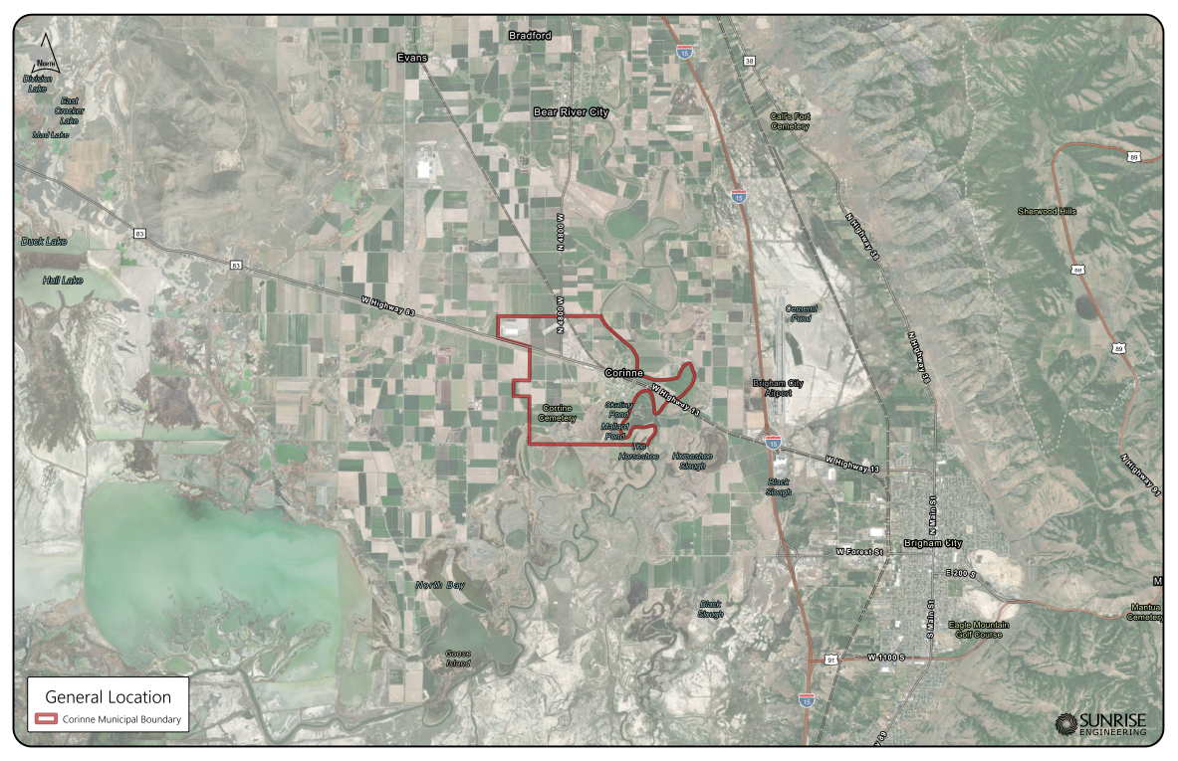Figure 1-1: Location

Scope and Purpose of General Plan
A general plan provides for the overall guidance of any City’s growth and sets the course and direction for future development. Policy decisions related to the City of Corinne’s land use decisions should all be consistent with the goals and policies outlined within the general plan. The Corinne General Plan is designed to provide policy direction to decision makers when considering development proposals and options for overall City development. The general plan should be updated and reviewed as necessary and updated every five years to ensure the document remains consistent with the City of Corinne’s vision and direction.

Authority
Title 10-9a-401 of the Utah State Code requires that “each municipality shall prepare and adopt a comprehensive, long-range general plan for:
(a) present and future needs of the municipality; and
(b) growth and development of all or any part of the land within the municipality.”
Utah State Code states, “the municipality may determine the comprehensiveness, extent, and format of the general plan.” At the time of this writing Corinne is a “City – under 1,000 population” as defined by the Utah State Code; therefore, the mandatory elements of this general plan update shall, at a minimum, consist of land use and transportation. The City of Corinne has decided to also include elements in the general plan consisting of housing, public services, historic resources, environment and conservation, and economic development.
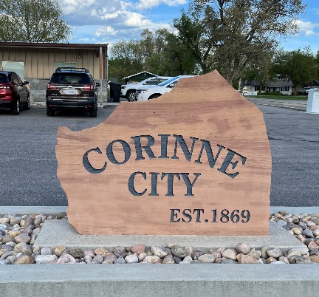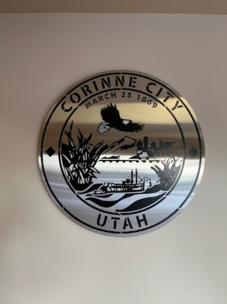

General Plan Update – Public Process Summary
In 2022 the City of Corinne contracted Sunrise Engineering, Inc., to engage the public, gather community input, and provide an updated general plan document.
The following is the process undertaken by Sunrise Engineering to update the Corinne General Plan:
- Data Collection:
  - Land use inventory – An assessment of zoning and land use patterns within the City’s corporate boundary and potential annexation areas.
  - Traffic circulation and patterns.
  - Collection of historic data.
- Community Preferences Survey and Stakeholder interviews:
  - A survey of the citizenry was conducted to determine opportunities, constraints, and preferences.
  - Stakeholder interviews were held with four groups: Ag Park, Agriculture, Landlords, Highway 13 Businesses.
- Public Participation:
  - Public meetings before the Corinne Planning Commission and City Council were held to obtain input. Citizens were encouraged to participate through a community wide survey, stakeholders’ meetings and an open house. Residents’ concerns and then incorporated those comments as much as possible in the general plan update.
  - Sunrise Engineering, as planning consultant also worked closely with the Corinne Steering Committee to gather input from Corinne residents for the plan goals and strategies.
  - Throughout 2022 Sunrise worked to update the general plan to reflect the vision, priorities, and goals outlined by Corinne citizens.
  - The updated general plan was presented by Sunrise Engineering to the Corinne Planning Commission and City Council at a public hearing for final comment and adoption in December 2022.
The document that follows represents a collaborative effort between Corinne residents, business owners, City staff, Sunrise Engineering, and numerous local and regional organizations. This collaboration is key to the success of the general plan as a tool to guide future development in the City of Corinne.

General Plan Themes
Below are the key general areas of concern that were identified through the community survey, steering committee meetings and City Council meetings.
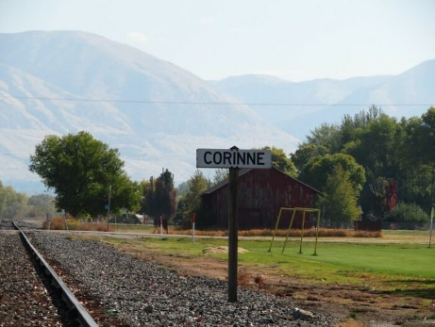
- Maintaining the Rural, Open and Charming Character of Corinne: Most residents live in Corinne for its rural, agricultural, small-town charm and want to keep that small town feeling. Development is starting to encroach from surrounding areas, with industrial development to the east that could have a negative impact on the community character. Residents believe that it is imperative to keep the rural, small town feel and control growth now and in the future.

- Large Lot/Agriculture: Corinne residents want a separation from urban development to the east. Developing into a suburb of the Brigham City metropolitan area is not desired. Large lot developments and preservation of the City’s agricultural and farming heritage is accomplished with the agricultural and rural density development at the parameter of the community.

- Infrastructure: Keeping up with infrastructure needs and requirements such as robust water and sewer services, a secondary water system, and street improvements is critical to the quality of life in Corinne and is an essential service.

- Code Enforcement: Maintaining an orderly community is important to the resident’s quality of life. Unkempt properties should be addressed, and existing codes enforced related to property maintenance.

- Open Space and Parks: Support parks and open space for recreational activities and community building events.

- Develop and Support for Local Businesses: Supporting of local businesses and restaurants and expansion of other commercial services is desired.

Demographic Data
Based on the 2020 Census Data the population of Corinne, Utah, is 809. (Source: 2020 Decennial Census). It is defined as a City by the State of Utah because its population is less than 1,000 people. Although some population change has occurred since 2020 the demographic information from the census still offers a good representation of the Corinne community. As evidenced in the rest of the State of Utah, growth continues to trend upward in the community and the rate of growth can be variable and somewhat unpredictable.
In 2020 the population of Box Elder County, Utah, was 57,666. The projected population of Box Elder County is estimated to increase to 89,997 by 2060, mainly driven by natural increase. If the City of Corinne follows the same demographic trend, the population could also increase by 64% to approximately 1327 residents.
Population issues – aging population over 65 increases from 13.2% to 26.4% in 2060. The share of the population under 18 is projected to decline as a share, from 31.6% in 2020 to 20.1% in 2060. The median age is projected to rise from 33.7 in 2020 to 45.6 in 2060. (Kem C. Gardner Long-Term Planning Projection Summary February 2022.)
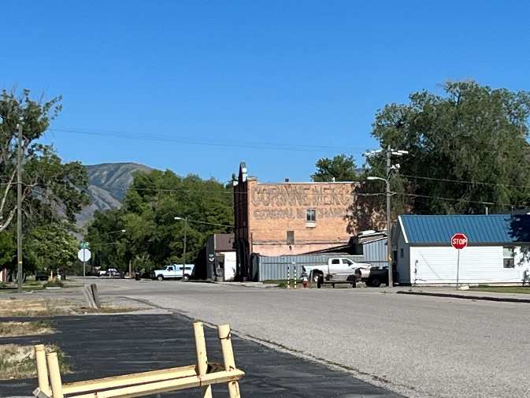
For more information regarding the history, culture, and vision of the City of Corinne, please visit https://www.corinnecity.com/.

Annexations
The City of Corinne presently has several square miles of property identified in its Future Land Use Map that could be annexed to provide for future growth. The City wants to ensure that only well-planned, cohesive growth occurs in the areas identified in the City’s future land use map. As such, the City reserves the right as provided under Utah State Code 10-2-4 to annex areas as identified within the annexation area policy plan and map.
The area east of Corinne is to be annexed as rural development occurs. The large lot rural density is meant as a buffer to expanding sprawl and industrial development. It is anticipated that the residential large lots will create a distinct density transition from Brigham City to the rural character of Corinne. This area will be residential uses that allow for small agricultural operation or family farms. The Bear River and the surrounding floodplain and wetlands will contribute to the open and rural character of Corinne.
The Box Elder County Zoning allows for RR-20, Rural Residential District-20,000 sq. ft. shown in brown, and A-20 Agriculture District – 20, shown in green. For annexation into Corine the RR-20 District, would need to conform to the Corinne General Plan and Future Land Use Map.
Box Elder County Zoning Map – October 2022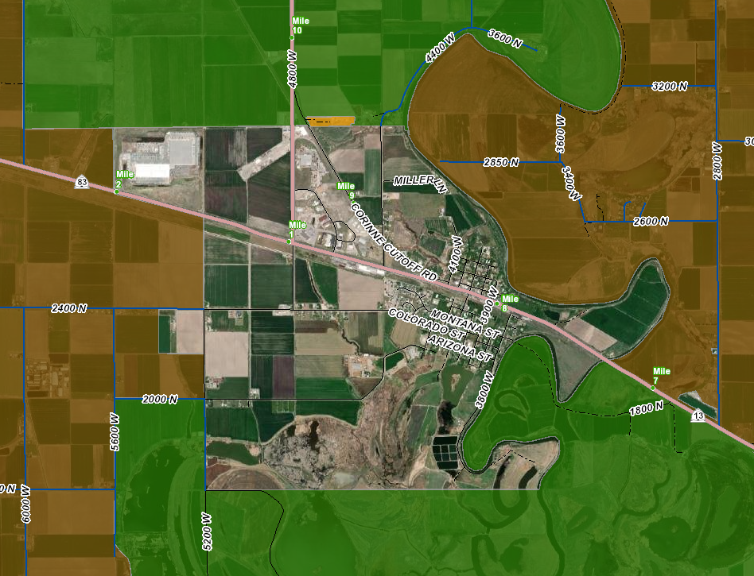
Box Elder County Zoning designations around Corinne are RR-20 (Rural Residential District – 20, 000 sq. ft.) and A-20 (Agriculture District – 20 acres). The areas to the north and south of Corinne at the 20-acre density are consistent with the Future Land Use goals for Corinne. However, the RR-20 to the east of Corinne and the Bear River should be rezoned if annexed to reflect the community desire for a more rural atmosphere.

Land Use

Purpose
The land use element of the general plan is a guide for the future development of the City and will provide a guide for City leadership when deciding upon future land use patterns, development, and vision of the City. The City can then balance the vision for City development and the goals, strategies, and actions contained within this general plan to ensure development meets the community desires as outlined.

Existing Conditions
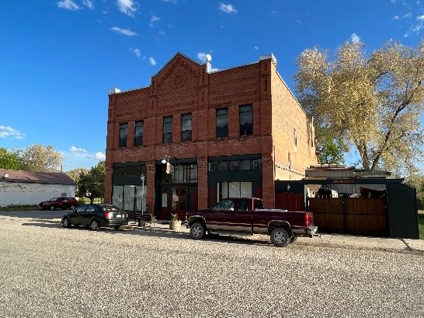
In 2022 land uses within the City of Corinne consist of undeveloped and natural property, low density residential, agricultural, historic resources, and a limited number of commercial businesses along Main Street. Most single-family homes are built on lots ranging from approximately 4,000 square feet in size to over 20 acres in size. Open space areas located around the City of Corinne are generally privately owned agricultural lands within the floodplain or wetlands of the Bear River.

Land Use Classifications
Land use designations are based on the current land uses and long-term desired land uses in a given area. The land-use policies in the Land Use Element of this Plan are intended to guide the basic land-use patterns of the City. Compatibility and safety are major concerns in the General Plan and can be achieved through land use planning.
The planned or future land use, as shown on the Future Land Use Map in Figure 2.1, reflects future land use conditions. This map should be used as a general guide to consider applications for zoning and land use changes. The purpose of the map is to reflect existing land use conditions and use the goals and policies to project future land-use development. This map will guide citizens, City officials and staff, developers, property owners, and others as they consider changes to how the land is used throughout the City and the land areas that may be annexed to meet City goals.
The Corinne Future Land Use Map has eight (8) land use designations.
      - Industrial (I) - Industrial areas provide limited locations for intensive, high-impact industrial activity such as mining, manufacturing, warehousing, assembly and storage involving large-scale machinery and structures. These uses should be located to minimize impact on the community and its natural resources such as viewsheds, pollution, noise and traffic.

      - Commercial (C) - The Commercial areas are intended to include larger scale, automobile-oriented commercial uses, offering accommodations or services to motorists or other large-scale, regionally focused commercial uses.

      - Mixed Use (MU) - Mixed-Use areas are intended to provide a variety of commercial, office and residential uses in a manner compatible with surrounding land uses.

      - Agricultural (1 Unit/20 acres) - Agriculture areas focus on existing agricultural land uses and are intended to support viable agricultural operations.

      - Estate Agricultural (1 Unit/5 Acres) - Estate Agricultural areas are intended to provide large lot residential development with accommodations for livestock. This use is intended to provide a semi-rural character single-family detached residential development.

      - Rural Residential (1 Unit/Acre) - The rural residential use provides for limited farming associated with residential uses. The large lots allow for residential development with a semi-rural character single-family detached residential development. The intended maximum density for this use is one residential unit per acre, although clustering is recommended to maintain large uninterrupted tracts of agricultural land or natural open space.

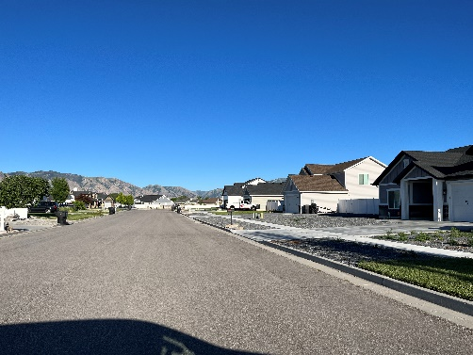
      - Residential (1 Unit/0.5 Acre) - Residential areas characterized by single-family detached residential development.

      - Residential Small (1 Unit/ 0.25 Acre): Residential Small are areas intended to provide a variety of single- and multi-family housing options to help meet existing and future housing needs. Single-family dwellings may be attached or detached. Multi-family dwellings may include townhomes, twin homes, or green-court style residences. Common open space is encouraged.
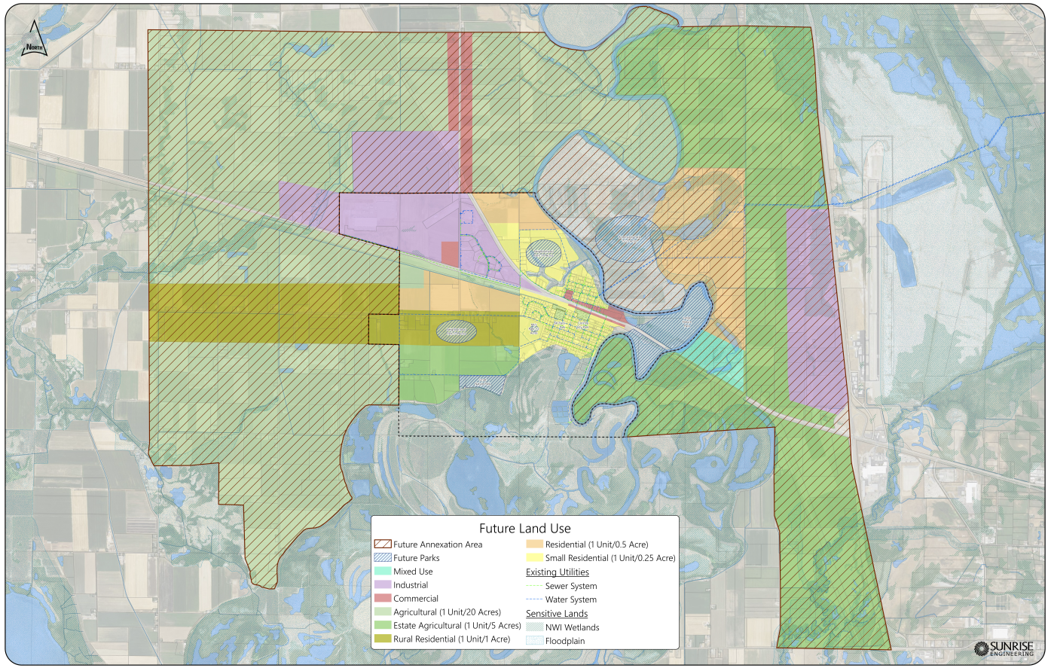 Figure 2-1: General Plan Map

Zoning
The intent of zoning within the City of Corinne is to provide for logical and cohesive development of the City. Permitted uses, conditional uses and setback requirements provide for logical and consistent development of the City while also providing property owners the latitude to enjoy their property. The following describes zoning classifications presently located within the City of Corinne Zoning Ordinance: The current zoning districts: A-1 Agricultural, B Business (B), R-1/R-2 Zone Residential, RT-2 Retail, Wetland and Cemetery.
Existing Zoning Categories –
- Agricultural Zone (A1)- one unit per (5 acre) this zone is established to provide areas where the growing of crops and raising of livestock can be encouraged and supported within the City. The A1 zone is intended to protect agricultural uses from encroachment of urban development until such time as residential, commercial, or industrial uses in such areas become necessary and desirable by the City.
- Residential Zone: Within the residential zone there are three zones, R1, R2, and DZ.
  - R1: four units per 1 acre – This is a single-family residential zone.
  - R2: two units per 1 acre – this is a single-family residential zone.
- Retail Zone (RT): This zone is for retail uses. No minimum lot size except as may be dictated by the off-street parking, adequate circulation, and site utilization requirements). Primarily for the accommodation of retail uses and retail areas which have been established in locations within or close to the central core of the community.
- Consolidated Business Zone (B): This district is established to provide for the accommodation of a wide variety of business activities. This zone will allow light and medium commercial use and light manufacturing and industrial uses. This zone is designed to accommodate clean manufacturing or industrial types of uses.

Major Land Use Themes
Two major land use themes were identified by the survey responses of Corinne residents:
1. Small City – Rural Feel: Most residents enjoy the City because it is rural, generally still agricultural and has a small-City charm. Residents want to continue to keep that feel to the City. A common goal is to preserve the City’s rural character and history in all future planning and development activities.
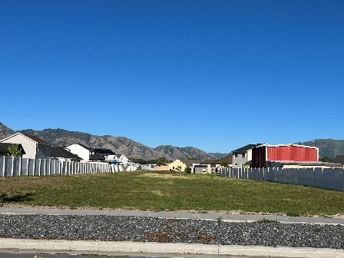
2. Controlled Development: Development must be planned accordingly and controlled so that the City of Corinne maintains its own character and does not become a continuation of suburban development from the east.

Land Use Goals and Policies
The following goals and policies provide specific actions to promote Corinne residents’ vision as discussed in the previous sections.
Goals | Strategy | Action
LU1 - Provide for responsible growth management through the logical extension of the City’s municipal boundary. | Annexation should occur prior to development. Annexing areas prior to development provides the City with an ability to influence development proposals so that those proposals will remain in keeping with City goals and values.  The Future Land Use Map land use designations should guide areas for annexation and density for any new development. | As per Utah Code Section 10-2-4, initiate the annexation process for those chosen areas referenced in the City’s annexation plan.
LU2 - Anticipate and encourage managed and planned growth. | Require new residential development to be compatible and consistent with the City’s historic land use patterns, adjacent developed lot sizes and the land uses as shown on the Future Land Use Map. | Review and update the City’s zoning ordinances and development standards to ensure compatibility with surrounding land uses in accordance with the land uses and densities in the Future Land Use Map.
 |  | Update the City’s zoning map to be compatible with the general plan map and land use designations.
 | Require new commercial development to be compatible with surrounding residential homes and development. | Proactively enforce land use and development standards existing in the Corinne Municipal Ordinance.
 |  | Require developers to post warranty bonds in accordance with State of Utah code to ensure completion of infrastructure related to project development.
 |  | Require compliance with the intent of the general plan when reviewing applications for changes in the land use and zoning.
 |  | Amend the zoning ordinance to allow for the establishment of agricultural protection areas in accordance with state code requirements.
 | As agricultural property owners request, preserve agricultural land through large lot zoning, conservation easements or other mechanisms. | Review the zoning ordinance to ensure agricultural practices are protected and encouraged in the appropriate zones. Update the zoning ordinance if necessary to maintain consistency in agricultural regulations/zones throughout City.
LU3 -Maintain the small-town, rural feel of Corinne. | Preserve the agricultural and historic heritage of Corinne with each land use decision by promoting and preserving agricultural uses compatibility with housing, agricultural uses and open spaces in the zoning ordinance and in land use decisions. | Promote community participation events such as farmer’s markets, local fruit stands, and other community related events.
 |  | Review the zoning ordinance to ensure that the proper mechanisms exist to enforce nuisance hazards.
LU4 -Maintain and promote an attractive and inviting living environment. | Consider design standards to beautifying and maintaining the City’s municipal assets, residential areas, open space areas, vistas, and other assets. | Proactively enforce nuisance issues to maintain the City’s values in a fair and even approach.
 |  | Pursue grant opportunities from the state and federal government for the upkeep and enhancement of beautifying roadways, the park, and preserving open space areas.
 |  | Work with UDOT on street beautification and infrastructure improvement grants for improvements to Highway 13.
Table 2-1: Land Use Goals, Strategies, and Actions

Historic Preservation

Purpose
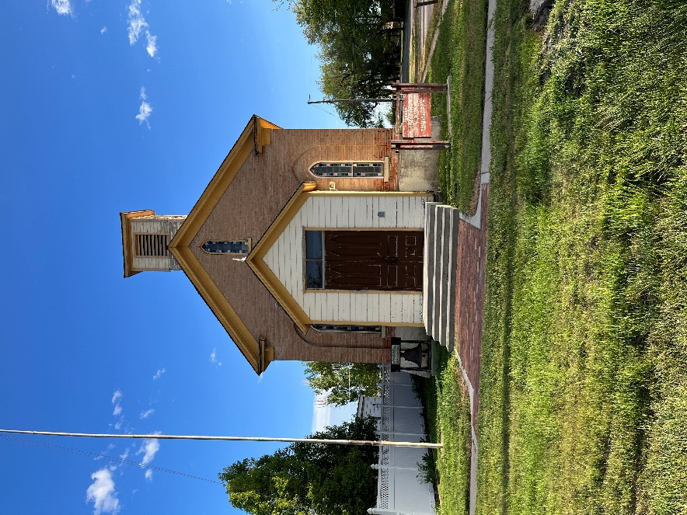
The City of Corinne has a unique history in the State of Utah. As a subset of the more prominent religion in the region it was set apart and yet still survives.
The purpose of the Historic Preservation element of the General Plan is to enhance, preserve, and protect historic structures and areas within the City.

List of Historic Sites and Structures
The following structures are of historic significance to Corinne that are still in place.
- Corinne Methodist Episcopal Church
- Hiram house Waterworks
- Hiram House Home
- J.W. Guthrie Home
- Cole Bank/Masonic Lodge (1890)
- Corinne Mercantile (Holmes Grocery) (1891)
- Methodist Church
Source: Corinne “A Unique Little Railroad Town in the West” 1969-2019

Historic Preservation Goals, Strategies, and Actions
Goal | Strategy | Action
HP1 -Support the restoration and maintenance of historic structures and properties in Corinne in order to conserve historic structures, areas, and history. | Develop an historic preservation ordinance and/or modify the existing ordinance. | Continue to define historic properties in Corinne and develop standards and regulations governing the identification, protection, restoration, maintenance, alteration, relocation, or removal of historic resources.
 |  | Clarify procedures for eligibility of listing of historic structures and areas. Create a landmark structure listing of all significant properties/structures/walls, etc.
 |  | Attempt to secure public and private funding sources to assist in preservation efforts. Consider all available grant opportunities.
HP2- Physically preserve historic sites and structures in Corinne. | Implement all existing governmental resources, programs, and guidelines available. | Encourage and consider implementation of the Secretary of the Interior's standards for the “Treatment of Historic Properties with Guidelines for Preserving, Rehabilitating, Restoring and Reconstructing Historic Buildings.”
 |  | Consider adopting a “Historic Preservation Overlay” zoning district to preserve existing historic resources and encourage those who qualify to place the overlay zone on the historic resource property.
 |  | Consider adopting flexible land use standards and development options as historic structures normally do not comply with present day development standards.
Table 3-1: Historic Preservation Goals, Strategies, and Actions
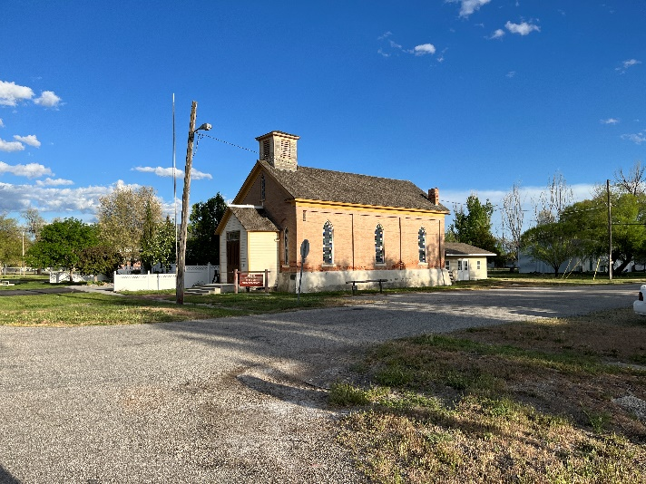

Transportation
The intent of the transportation element of the general plan is to address various aspects of the transportation system in the City of Corinne. Discussion regarding the City’s rights-of-way, infrastructure, and strategies for future and continued improvements to the City’s transportation system follow.
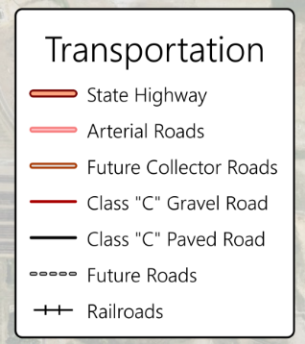
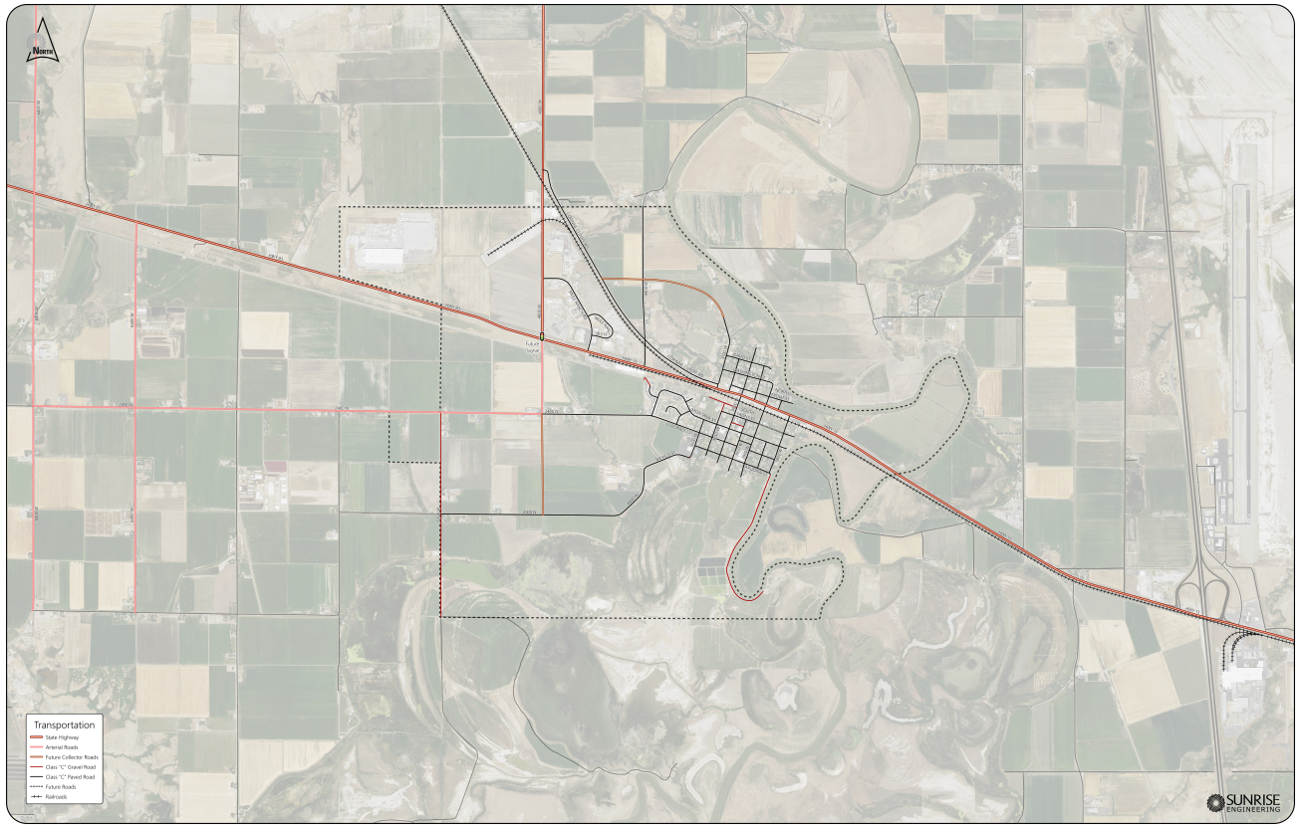
Figure 3-1: Corinne Transportation Map

Existing Conditions
Highway 13 (Main Street) is the main arterial road for Corinne. There is an original township street grid of approximately thirty-five blocks. Highway 13 turns north at 4800 West and is an arterial to the north. Highway 13 is the primary thoroughfare in City and provides access to east and west through the City.
On the west side of Corinne Highway 13 turns north and Highway 83 continues west. These state highways service commercial and agricultural uses on the west end of Corinne. (see Corinne Transportation Map Figure 3-1).
Figure 3-1: Corinne Transportation Map

Future Transportation Issues
Transportation has a significant impact on the quality of life for residents in and around Corinne. Corinne should continue to address the increased needs of its citizenry by seeking a variety of funding options and grants to upgrade and plan for roadway improvements and alternate modes of transportation. Semi-annual discussions with the Utah Department of Transportation should be pursued to discuss road improvements and rant opportunities for improvements.
As development occurs transportation routes that will allow the City to identify and preserve important corridors for pedestrian trails, access to public lands, ATV trails, equestrian paths, bikes, and other important modes of transportation is critical.
The issue of access in to and out of the City needs to be analyzed and addressed with UDOT as the City continues to experience growth pressure. The Utah Department of Transportation must be an integral part of any plans that impact Highway 13 for transportation improvements to Corinne.

Roadway Design
A safe and sound transportation system is essential for any city. New roads should be designed to give proper access to emergency vehicles and should be well maintained. Also, roadways, bikeways, and walkways should be designed in a way that all people can equally access and use the transportation system. The City of Corinne has identified existing and future transportation corridors as shown on the Corinne Transportation Map (Figure 3) and has adopted a hierarchal system of roadways to assist in providing for connected traffic circulation. Table 4-1 is provided as a guide regarding the hierarchal road system, average daily trips for each classification, typical speeds, and access points.

A critical factor to the safety and function of the transportation system is access management. Access management is the practice of coordinating the location, number, spacing and design of access points to minimize site access conflicts and maximize the traffic capacity of a roadway. Corinne will need to coordinate access management requirements with UDOT as the City experiences growth pressures.

TABLE 4-1 Road Type
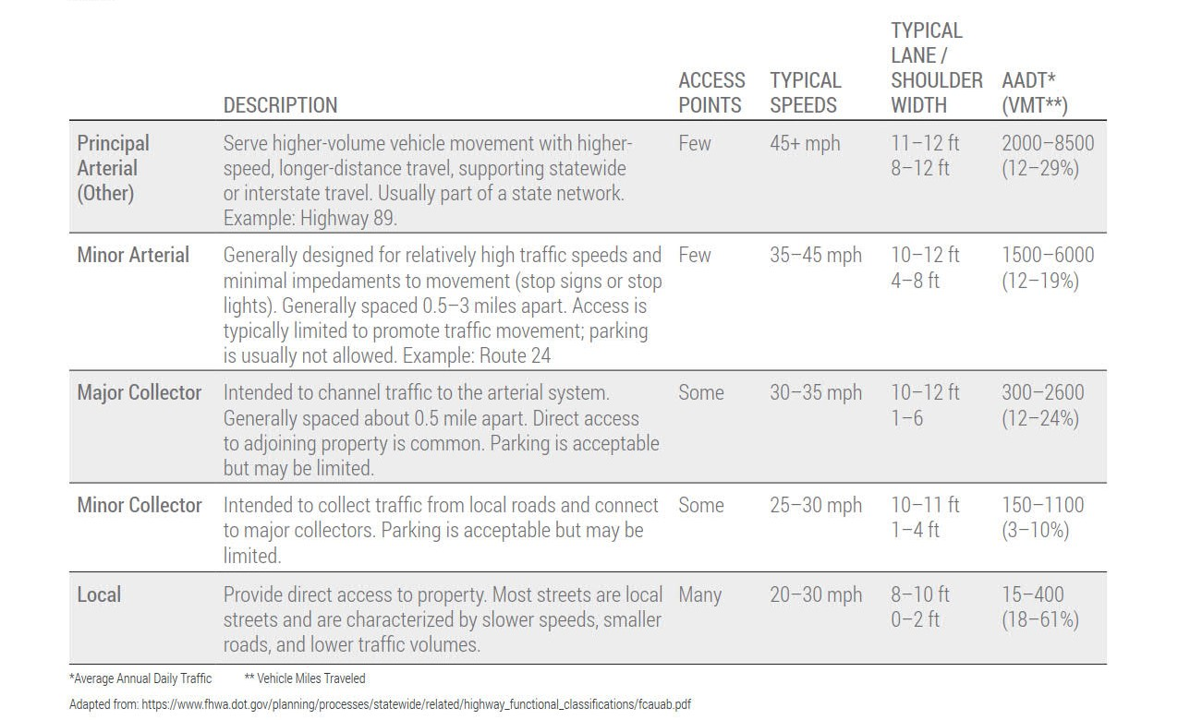

Parking
Parking congestion is not currently a problem in Corinne; however, parking of trucks and trailers with ATVs is sometimes an issue during certain hours of the day. There are presently no organized parking areas in City providing appropriate parking for commercial vehicles moving through Corinne. As development occurs additional parking should be required.

Transportation Goals and Policies
Goals | Strategy | Action
Continue to provide a safe and robust roadway network. | Follow transportation plan in implementation of road types with new development and city growth. | Develop a five-year CIP plan for the continual repair, replacement, and maintenance of the City’s road system.
 |  | Inspect the roadway system for maintenance and signage issues. Repair all identified issues.
 |  | Look for any available grant and funding opportunities to pave, maintain and upgrade the City’s transportation system.
 |  | Require new development to pay traffic impact fees and provide traffic impact studies to analyze traffic mitigation measures.
 |  | The City should continue to explore active transportation opportunities that will connect its City core with the trails, bikeways, and recreational facilities that surround the City.
 |  | Work with UDOT and Box Elder County regarding continual improvements to Highway 13 and in regard to access and potential improvements from Interstate 15.
Table 4-2: Transportation Goals and Policies

Public Services, Facilities and Recreation

Location, Services and Existing Conditions
The City of Corinne is governed by a volunteer mayor with support of a volunteer City Council. The City also has a volunteer planning commission. The City of Corinne Hall is located at 2420 N 4000 W. The Mayor, City Council, and city employees provide the most efficient and effective service to the City residents while also operating within its budget. The community also has active volunteers to assist with programs and events. Police service is provided by the Box Elder County Sheriff’s Office. Emergency fire service is provided by the City of Corinne Fire Department on 3950 West and supplemented with volunteers.
The City of Corinne boasts one community park (Corinne Park) and is located behind the City of Corinne Hall on Front Street. The parks consist of playing fields, a playground, large grassy areas, trees, and a restroom.

Utilities

Water
The City of Corinne is the domestic water purveyor for the City.
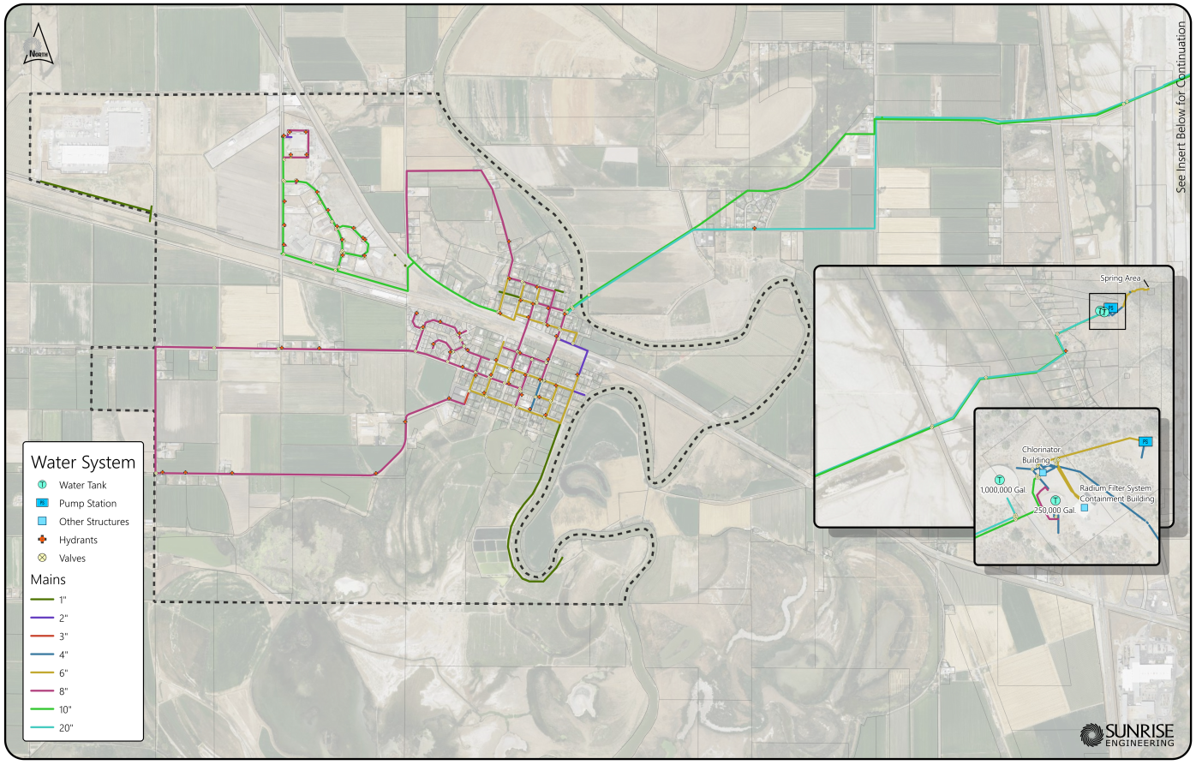

Wastewater

The City of Corinne wastewater distribution system.
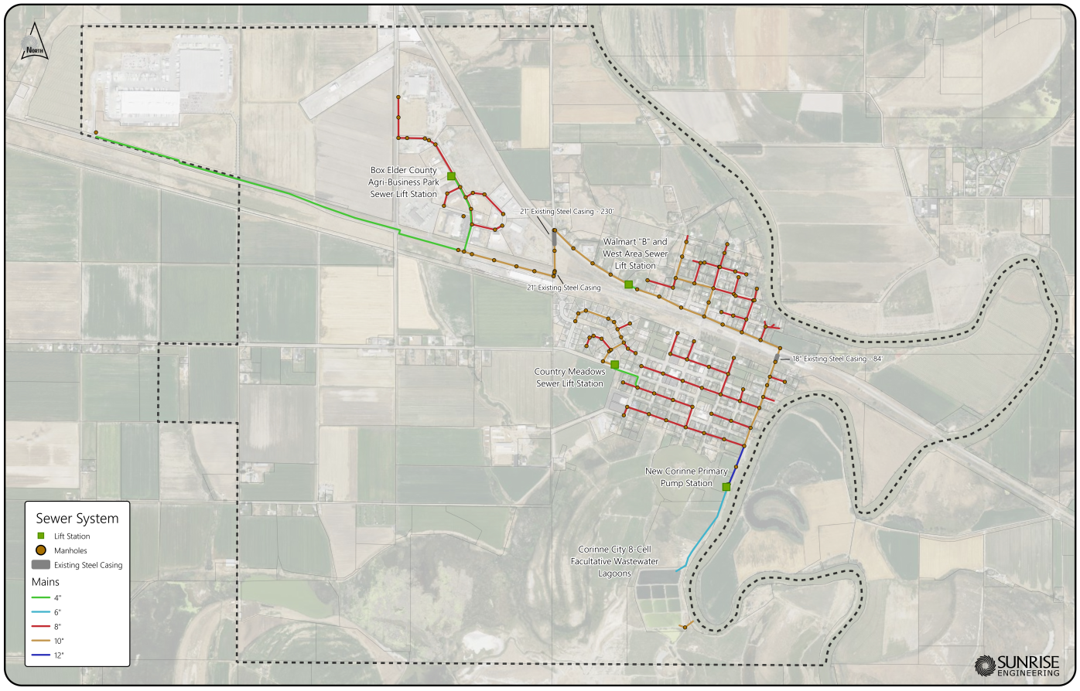

Electricity, Gas, Solid Waste

Electricity to the City of Corinne is provided by Rocky Mountain Power. Natural gas is provided by Dominion Energy and solid waste service is provided by Box Elder County.

Drainage
Drainage consists of sheet flow into troughs, ravines, and gullies. Occasional flooding in Corinne has been an issue in the past and the City has tried to address such issues as resources allow.

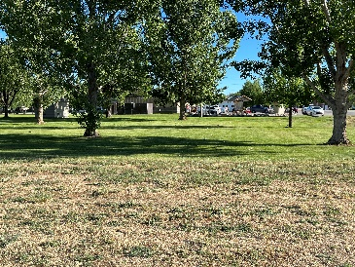

Public Services, Facilities and Recreation Goals, Strategies and Actions
Goals | Strategy | Action
PS1 -Provide for efficient and effective City administration and essential public services. | Assess, maintain, adjust, and enhance service levels to the community. | Continually recognize changes in community needs and reprioritize resources (fiscal and otherwise) to address such needs.
 |  | Continue to assess and anticipate budget issues, adjust the budget as necessary and maintain an appropriate reserve in case of emergency or other unforeseen issues.
 |  | Continue to work with and support the Box Elder County Sheriff’s Office regarding issues related to crime, speeding and crime prevention in City.
 |  | Continue training and education programs with the Fire Department to provide the best emergency service possible in order to decrease response times to the community.
 |  | As the population grows, continue to evaluate, and assess the educational needs of the community. Additional resources provided by Box Elder County, or the Box Elder County School District may be necessary to properly service the community’s educational needs.
 |  | Develop a five-year capital improvement program so that a comprehensive approach can be taken to provide for storm water, street and possibly wastewater service to the community.
PS2 -Provide the highest quality utility service to the community. | Plan for expansion, extension or establishment of water, storm water and wastewater service to the community and develop redundancy in all systems. | Continue to apply for grants to address any drainage issues that still exist in the City.
 |  | Work to upgrade old water lines, storage, and delivery systems to better provide for redundancy, security, and safety in the City’s water system.
 |  | Work and cooperate with the Bear River Water Conservancy in regard to providing the highest quality water possible to residents and in helping The City of Corinne cope with growth and maintenance of the system.
 |  | Provide sufficient funding for park maintenance and recreational activities.
 |  | Continue to allow and support community events at The City of Corinne Park and City Hall.
PS3 - Expand recreational opportunities and meeting space to the best extent possible for residents of the City. | Support, maintain and encourage activities and events at The City of Corinne Park and at City Hall. | Look to establish cultural opportunities and events that unite the community and provide for community cohesiveness.
 |  | Pursue sponsorships and other private funding mechanisms to establish new events, celebrations, summer outdoor concerts, presentations and activities at The City of Corinne Park and City Hall.
 |  | Pursue funding opportunities to establish organized walking and biking trails in City which can connect to existing established trails on the outskirts of City.
Table 5-1: Public Services, Facilities and Recreation Goals, Strategies and Actions

Environment and Conservation

Existing Condition and Key Findings
The City of Corinne is located in a unique area of Utah and boasts beautiful views of mountains and the Bear River. The Bear River Migratory Bird Refuge is to the south of the City. The environment and conservation element of this general plan addresses strategies in order to preserve the unique environmental resources of the City for the enjoyment of future generations. Moreover, the general plan provides for enhancement and protection of those unique resources as the City grows. Preservation of the environment is an essential and critical part of the overall development strategy of the City of Corinne and should be given equal consideration when new development is proposed.

The City of Corinne – Environment and Public Lands
The City of Corinne has a unique and beautiful environment characterized by an abundance of natural resources, plant, and animal habitat. In order to maintain the character and quality of Corinne’ natural environment, it is important to take measures to protect valued natural resources and surrounding agricultural land. These natural resources not only contribute to the aesthetic character of the City, but also to the local economy and the welfare of Corinne residents. In order to balance the protection of Corinne’ environmental resources with private property rights, the City must make expectations clear regarding protection of unique environmental resources when development is proposed. Taking an active role in regard to the administration and management of surrounding public lands is essential with regard to the manner in which such lands are preserved for the benefit of City residents and visitors.

Environment and Conservation Goals and Policies
Goals | Strategy | Action
E1- Ensure and preserve environmentally sensitive areas such as wetlands and river habitat. | To preserve irreplaceable community assets for future generations, limit development in those areas. | Designate areas as open space that are valued and have a significant impact on the environment.
 |  | Work with FEMA to update flood zone maps.
 |  | Upon initial development submittal, make expectations known with the development community that areas of intrinsic value will be preserved.
 |  | Continue to collaborate with local agencies in order to ensure that the City of Corinne plays an active role in regulation and use decisions governing public lands surrounding the City.
Table 6-1: Environment and Conservation Goals and Policies

Economic Development
A successful economic development strategy is essential to the strength and security of any municipality. Corinne’ local economy has competitive strengths and economic opportunities. The general plan economic development goals seek to establish and maintain balanced economic drivers presently operating within the community as well as support future business ventures.
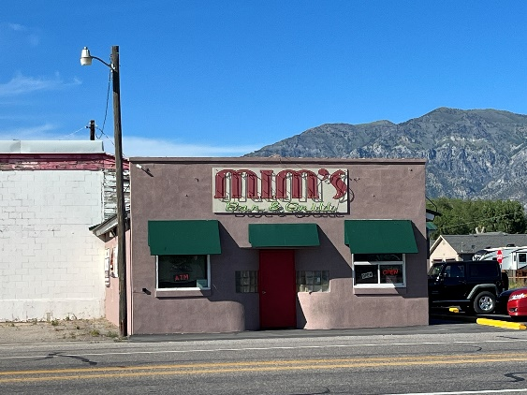
The economic development element provides an approach and framework to maintain the City’s economic base while also providing guidance where potential economic opportunities may be present. A strong local economy not only provides residents with a high quality of life but also enhances local government revenues to better provide essential public services. In order to prepare for a balanced economy, broad goals, strategies, and actions are provided in this general plan to guide future economic development efforts. The economic development element goals are meant to be long-term in nature and implementation, flexible, and provide an organizational framework to help guide decision makers in responding to differing market conditions.

Existing Conditions
Presently the City of Corinne has a few commercial or retail establishments in Corinne. There are two eating establishments (Golden Spike Restaurant and Mimi’s Café) and two convenience store/gas stations along Highway 13. However, there are numerous businesses located primarily on the west end of Corinne with the Walmart Distribution Center having the largest impact.

Economic Development Goals and Policies
Goals | Strategy | Action
ED1 - Promote a strong and diversified economic base by attracting quality businesses and encouraging existing businesses to expand. | Promote, recruit, and encourage new businesses that can fill gaps in the range of goods and services currently available. | Adopt clear development standards for the commercial areas of Corinne.
ED2 - Ensure fiscal viability for the City by pursuing a diversified local business base that provides growing sales and property tax revenues to pay for municipal operations. | Promote the City’s assets, community, and business-friendly environment to prospective commercial developers. | Expand retail and visitor-serving opportunities by encouraging an appropriate mix of revenue-generating land uses in an effort to maintain a competitive edge and a strong sales tax base.
 |  | Provide areas within City for commercial establishment and expansion.
 | Coordinate with local and state agencies on economic development issues. | Work with State of Utah agencies for assistance with establishing economic development programs in rural communities.
 |  | Work with the Box Elder County Economic Development Council to help promote the City of Corinne’s resources and economic potential.
Table 7-1: Economic Development Goals and Policies

Housing

Existing Conditions and Key Housing Issues
Housing in Corinne currently consists of single-family homes on lots ranging in size from approximately 7,000 square feet to over five acres in size. The smaller lots are generally located in the older area of Corinne. The 2020 census states that there are 288 homes in Corinne. Single family homes comprise 99 percent of available housing. The average household size is 2.8 persons. Approximately 97 percent of the homes are owner occupied. While the majority of the housing stock in Corinne is single-family, the architecture is varied and unique.
Currently, the median household income for Box Elder County, Utah, is $63,573 (US Census 2022). The average home price in the Box Elder County area in February 2022, is $450,000 (Realtor.com.) As with Box Elder County and the rest of the State of Utah, Corinne has experienced housing price increases.

Housing Goals and Policies
The following goals and policies provide specific actions to promote affordable housing options while maintaining Corinne residents’ vision as discussed in the previous sections.
Goal | Strategy | Action
H1 - Address the critical need for moderate income housing in the City. | Employ Utah State guidelines and strategies to provide for moderate income housing. | Consider all grant opportunities for moderate income housing.
Table 8-1: Housing Goals and Policies

Appendix A – Corinne Census and Demographic Data
Population |  |  | Housing – Total Housing Units |  | Occupied Housing Units
2010 |  | 820 | 2010 | 352 | 2010 | 304
2020 |  | 864 | 2020 | 401 | 2020 | 359
Absolute Change |  | 44 | Absolute Change | 49 | Absolute Change | 55
% Change |  | 5% | % Change | 14% | % Change | 18%
Vacant Housing Units |  |  | Income
2010 | 48 |  | Median House Income (2019) |  |  | $48,993
2020 | 42 |  | Changes in Median Household Income Between 2000 and 2019 |  |  | +18.8%
Absolute Change | -6
% Change | -13% |  | Per Capita Income in 2019 |  |  | $34,856

Sources:
Utah Long-Term Planning Projections: A Baseline Scenario of Population and Employment Change in Utah and its Counties
Corinne, Utah (UT 84307) profile: population, maps, real estate, averages, homes, statistics, relocation, travel, jobs, hospitals, schools, crime, moving, houses, news, sex offenders (city-data.com)

Appendix B – Box Elder County Growth Projections
10 Year Snapshots
 | Population |  |  | Employment |  | Households
Year | Population | Annual Growth Rate | Median Age | Employment | Annual Growth Rate | Households | Annual Growth Rate | Persons Per Household
2020 | 57,886 | n/a | 37.5 | 29,826 | n/a | 18,678 | n/a | 2.9
2030 | 67,637 | 2.90% | 42.3 | 35,753 | 2.30% | 23,171 | 3.60% | 2.7
2040 | 75,494 | 2.10% | 45.5 | 38,514 | 1.60% | 27,788 | 2.50% | 2.5
2050 | 83,130 | 1.60% | 47.7 | 41,233 | 1.10% | 32,685 | 2.20% | 2.4

Sources:
Projections-Brief-Final.pdf (utah.edu)
Utah Long-Term Planning Projections: A Baseline Scenario of Population and Employment Change in Utah and its Counties

Appendix C – Corinne Zoning Map
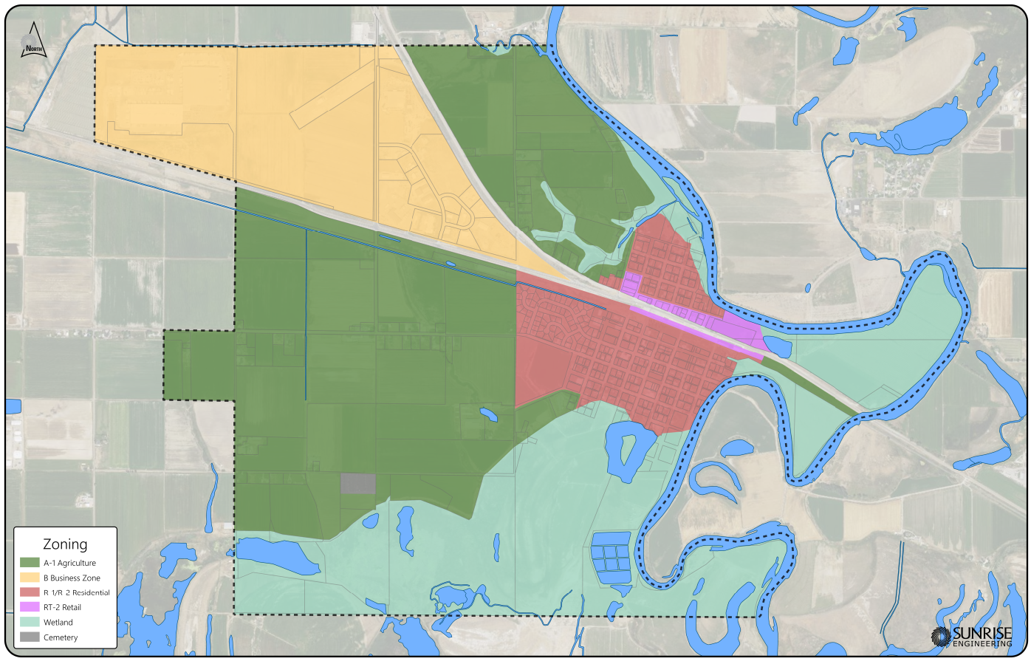

Appendix D – Recommended Action Items
- Update the City Zoning Code to better align with new General Plan goals and policies.
- Update the City Zoning Map to reflect any changes to the desired uses.
- Adopt clear commercial standards for site improvements such as parking, landscaping and architectural requirements.
- Develop of Park and trails plan.

Appendix E – Summary of Survey Results
The following is a summary of the community survey.
Most of the Corinne’s population are full-time residents and homeowners with residentially zoned property (75%). 53% of the population has lived in Corinne for more than 20 years but 21% of the population has only lived in Corinne for 5 years of less. The average respondent is 45-65 years old, is either employed full-time or is retired with no children at home.
A substantial 73% of the respondents rate the quality of life in Corinne either as Very Satisfied (47%) or Satisfied (36%). Only six respondents (9%) stated that they were Dissatisfied.
Land Use
Preserving agricultural land, and limiting new development, heavy manufacturing and warehouses are the highest priority for land uses in Corinne. There is moderate (57%) support for one acre or greater lot sizes and light manufacturing (50%). The promotion of tourism is supported by 41% of the population but new commercial uses to support tourism is only favored by 21% of the respondents. There is strong opposition to Higher Density Development (over 8 dwelling units/acre) 82%, and 87% of the respondents are opposed to a large-scale resort development.
Housing
The community is favors encouraging moderate income housing with 37% in favor and 38% neutral and only 21% opposed. Similar numbers support architectural standards and 665 support height regulations. Second units on the same property are opposed by 47% of the community. A strong majority (86%) of the community favor single-family residential on lots larger than ¼ acre. In the past 5 years 59% believe that the growth over the last five years has been too much/ too fast, 37% feel that it is the right pace.
Transportation
Regarding transportation issues there are only moderate majorities who support items like: street lighting (62%), Provide improved water availability (57%), restrict parking of semi-trucks (56%).
Recreation
93% of the respondents are in favor of protect rivers, streams, or other environmentally sensitive land, from development. 46% are in favor of regulating outdoor lighting. 60% of the community is opposed to adding community pool.
Community
A rural way of life is the most loved attribute of Corinne. This is further supported by support for: Preserving open space (87%), preserving the rural character of the city (79%). Adding a supplemental back up water source to the community system is also a high priority for 78% of the respondents.

Corinne General Plan Update - Survey Responses August 2022
260 surveys were mailed, 78 responses were received.

1. I am a:
A: Business owner | 5 | 5%
B: Full-time resident | 49 | 46%
C: Part-time resident | 1 | 1%
D: Non-resident | 0 | 0%
E: Homeowner | 50 | 47%
F: Vacant property owner | 2 | 2%
E: Other | 0
2. How long have you lived in Corinne?
A: I am not a resident | 0 | 0%
B: 5 years or less | 14 | 21%
C: 5 to 10 years | 9 | 13%
D: 10 to 20 years | 9 | 13%
E: 20+ years | 36 | 53%
3. I own property in Corinne that is zoned as:
A: Agricultural | 12 | 17%
B: Commercial | 1 | 1%
C: Residential | 54 | 75%
D: I rent a home | 0 | 0%
E: I rent a business | 0 | 0%
F: Don’t Know | 5 | 7%
4. How would you rate your satisfaction with the quality of life in Corinne?
A: Very satisfied | 33 | 47%
B: Satisfied | 25 | 36%
C: No Opinion/Neutral | 6 | 9%
D: Dissatisfied | 6 | 9%
E: Very Dissatisfied | 0 | 0%
5. The City of Corinne should (Land Use):
 |  | In Favor | Neutral | Opposed | No Opinion
Preserve agricultural land |  | 86% | 13% | 1% | 0%
Limit new residential development |  | 69% | 24% | 6% | 1%
Limit heavy manufacturing |  | 67% | 25% | 6% | 2%
Limit warehouses |  | 60% | 32% | 6% | 2%
Support higher density development (over 8 dwelling units/acre) |  | 0% | 18% | 82% | 0%
Support medium density development (4-6 dwelling units/acre - 7,000 to 10,000 square foot lots) |  | 21% | 16% | 61% | 1%
Support half-acre lots and development (2 dwelling units/acre) |  | 41% | 28% | 28% | 3%
Support new 1-acre or greater sized lots and development |  | 57% | 29% | 13% | 1%
Support light manufacturing development |  | 52% | 22% | 22% | 4%
Restrict short-term (less than 30 days) rentals |  | 60% | 16% | 22% | 1%
Promote tourism |  | 41% | 41% | 16% | 3%
Support large scale resort-type developments |  | 2% | 11% | 87% | 0%
Support tourist commercial development such as motels, gas stations, and restaurants |  | 21% | 30% | 47% | 2%
Support annexing more property into the city |  | 18% | 35% | 41% | 6%
Provide new commercial growth in Corinne |  | 37% | 33% | 27% | 2%
6. The City of Corinne should (Housing):
 |  | In Favor | Neutral | Opposed | No Opinion
Encourage housing for moderate income residents (Corinne City Moderate Income is between $29,279-$46,847) |  | 37% | 38% | 21% | 4%
Provide standards for the architecture of new homes |  | 36% | 29% | 29% | 7%
Allow for second units on the same property as an existing home |  | 26% | 24% | 47% | 3%
Regulate the maximum height of buildings in residential zones |  | 66% | 30% | 3% | 1%
7. What types of housing would you like to see more of in Corinne?
Single Family Residential on Smaller Lots (Less than .25 acres) |  | 32%
Single Family Residential on Larger Lots (.25 acres or more) |  | 86%
Apartments |  | 2%
City Homes |  | 4%
Cluster Homes |  | 26%
Patio or Retirement Homes |  | 35%
Homes Priced Below Moderate Income |  | 23%
Homes Priced Above Moderate Income |  | 37%
NA |  | 2%

8. How would you describe the growth of the residential housing market in the past 5 years in Corinne?
A: Too much/too fast |  | 59%
B: Not enough/too slow |  | 5%
C: At the right pace |  | 37%
9. The City of Corinne should (Roads/Transportation/Utilities):
 |  | In Favor | Neutral | Opposed | No Opinion
Enact a street paving and/or upgrade program |  | 44% | 36% | 8% | 12%
Require new developments to provide for curbs, gutters, and sidewalks |  | 54% | 19% | 22% | 6%
Provide street lighting |  | 62% | 24% | 11% | 3%
Improve access to city (working with regional partners) |  | 25% | 45% | 15% | 15%
Provide improved water availability |  | 57% | 31% | 3% | 8%
Develop a more robust storm water drainage system |  | 51% | 32% | 8% | 8%
Restrict parking of semi-trucks/equipment on city streets |  | 56% | 23% | 17% | 5%
Add broadband or fiber to city utilities |  | 26% | 32% | 30% | 12%
Put sidewalks throughout city |  | 18% | 32% | 46% | 4%
Restrict ATV use on city streets |  | 14% | 31% | 55% | 0%
Have bicycle lanes |  | 16% | 29% | 51% | 5%
Accommodate horses |  | 54% | 33% | 10% | 3%
Increase trails |  | 45% | 33% | 18% | 3%
Increase public transportation opportunities |  | 27% | 39% | 30% | 3%

10. The City of Corinne should (Recreation):
 |  |  |  |  |  | In Favor |  |  |  | Neutral |  |  |  | Opposed |  |  |  |  | No Opinion
Protect rivers, streams, or other environmentally sensitive land, from development |  |  |  |  |  | 93% |  |  |  | 6% |  |  |  | 1% |  |  |  |  | 0%
Support new recreation projects (parks, trails, sports courts/fields) |  |  |  |  |  | 37% |  |  |  | 41% |  |  |  | 21% |  |  |  |  | 0%
Regulate outdoor lighting to maintain dark night skies |  |  |  |  |  | 46% |  |  |  | 38% |  |  |  | 13% |  |  |  |  | 3%
Support a community center or recreation building |  |  |  |  |  | 30% |  |  |  | 37% |  |  |  | 34% |  |  |  |  | 0%
Add a community pool |  |  |  |  |  | 11% |  |  |  | 26% |  |  |  | 60% |  |  |  |  | 3%
Increase arts or city recreation programs |  |  |  |  |  | 25% |  |  |  | 41% |  |  |  | 32% |  |  |  |  | 1%
11. The City of Corinne should (Economic Development):
 |  |  |  |  |  | In Favor |  |  |  | Neutral |  |  |  | Opposed |  |  |  |  | No Opinion
Promote the city as a tourist destination |  |  |  |  |  | 17% |  |  |  | 43% |  |  |  | 37% |  |  |  |  | 3%
Provide incentives or fee waivers for commercial development |  |  |  |  |  | 8% |  |  |  | 21% |  |  |  | 63% |  |  |  |  | 7%
Provide incentives or fee waivers for industrial development |  |  |  |  |  | 9% |  |  |  | 17% |  |  |  | 68% |  |  |  |  | 6%
Provide incentives or fee waivers for new employment opportunities |  |  |  |  |  | 21% |  |  |  | 29% |  |  |  | 47% |  |  |  |  | 3%
Support special events to bring business to city |  |  |  |  |  | 24% |  |  |  | 41% |  |  |  | 24% |  |  |  |  | 10%
Support architectural guidelines for commercial development |  |  |  |  |  | 46% |  |  |  | 31% |  |  |  | 20% |  |  |  |  | 3%
Increase the amount of land zoned for commercial use |  |  |  |  |  | 9% |  |  |  | 28% |  |  |  | 55% |  |  |  |  | 7%
Add commercial zoning (in a specific city location) |  |  |  |  |  | 15% |  |  |  | 33% |  |  |  | 46% |  |  |  |  | 6%
Beautify Main Street or other commercial areas |  |  |  |  |  | 54% |  |  |  | 24% |  |  |  | 18% |  |  |  |  | 4%
12. How would you describe the growth of the commercial development in the past 5 years in Corinne?
A: Too much/too fast |  |  |  | 25 |  | 38%
B: Not enough/too slow |  |  |  | 7 |  | 11%
C: At the right pace |  |  |  | 34 |  | 52%
13. What types of future developments would you like to see in Corinne?
Single-family residential |  |  |  | 75 |  | 45%
Multi-family residential |  |  |  | 8 |  | 5%
Planned/Multi Use Subdivisions |  |  |  | 6 |  | 4%
Retail Commercial |  |  |  | 16 |  | 10%
Dining/Restaurants |  |  |  | 26 |  | 16%
Industrial |  |  |  | 5 |  | 3%
Light Manufacturing |  |  |  | 19 |  | 11%
Heavy Manufacturing |  |  |  | 4 |  | 2%
Extraction/Mining |  |  |  | 0 |  | 0%
Redevelopment of blighted areas |  |  |  | 8 |  | 5%
14. What do you especially love about Corinne? What makes it ‘home’ to you?
 | 1 | 2 | 3 |  | 4 |  | 5 |  | 6 |  |  | 7 |  |  | 8 |  | 9 |  |  | 10
Rural way of life | 60% | 17% | 16% |  | 0% |  | 2% |  | 2% |  |  | 2% |  |  | 0% |  | 0% |  |  | 2%
Views | 7% | 21% | 16% |  | 21% |  | 21% |  | 10% |  |  | 3% |  |  | 0% |  | 0% |  |  | 0%
Open Space | 12% | 29% | 22% |  | 22% |  | 10% |  | 0% |  |  | 0% |  |  | 0% |  | 0% |  |  | 0%
Recreational Opportunities | 0% | 3% | 8% |  | 11% |  | 8% |  | 5% |  |  | 11% |  |  | 13% |  | 13% |  |  | 5%
Educational Opportunities | 6% | 0% | 3% |  | 0% |  | 0% |  | 6% |  |  | 9% |  |  | 38% |  | 38% |  |  | 29%
Low Taxes | 9% | 9% | 9% |  | 7% |  | 18% |  | 20% |  |  | 14% |  |  | 5% |  | 5% |  |  | 2%
Local Businesses | 0% | 3% | 3% |  | 6% |  | 17% |  | 11% |  |  | 26% |  |  | 20% |  | 20% |  |  | 0%
Feeling of Safety or Security | 6% | 11% | 30% |  | 17% |  | 19% |  | 11% |  |  | 2% |  |  | 6% |  | 6% |  |  | 0%
Sense of Community/Community Events | 8% | 8% | 21% |  | 11% |  | 9% |  | 15% |  |  | 19% |  |  | 0% |  | 0% |  |  | 2%
It’s where we have always lived | 33% | 4% | 4% |  | 4% |  | 0% |  | 2% |  |  | 2% |  |  | 9% |  | 9% |  |  | 37%
15. The City of Corinne should (City Goals):
 |  |  |  |  |  | In Favor |  |  |  | Neutral |  |  |  | Opposed |  |  |  |  | No Opinion
Support a sheriff substation in city |  |  |  |  |  | 34% |  |  |  | 21% |  |  |  | 40% |  |  |  |  | 6%
Support the establishment of a library |  |  |  |  |  | 24% |  |  |  | 37% |  |  |  | 36% |  |  |  |  | 3%
Support education opportunities such as a college satellite campus |  |  |  |  |  | 16% |  |  |  | 35% |  |  |  | 48% |  |  |  |  | 1%
Support historic preservation |  |  |  |  |  | 68% |  |  |  | 19% |  |  |  | 13% |  |  |  |  | 0%
Preserve the rural character of the city |  |  |  |  |  | 79% |  |  |  | 16% |  |  |  | 5% |  |  |  |  | 0%
Preserve open space |  |  |  |  |  | 87% |  |  |  | 8% |  |  |  | 5% |  |  |  |  | 0%
Provide standards and enforcement for unkempt properties |  |  |  |  |  | 58% |  |  |  | 27% |  |  |  | 13% |  |  |  |  | 2%
Regulate short-term rentals |  |  |  |  |  | 71% |  |  |  | 16% |  |  |  | 10% |  |  |  |  | 3%
Specify growth areas around Corinne |  |  |  |  |  | 46% |  |  |  | 34% |  |  |  | 11% |  |  |  |  | 9%
Supplemental or backup water source for the community system |  |  |  |  |  | 78% |  |  |  | 19% |  |  |  | 1% |  |  |  |  | 1%
Create a farmers' market |  |  |  |  |  | 52% |  |  |  | 27% |  |  |  | 20% |  |  |  |  | 2%
Promote city history for tourism |  |  |  |  |  | 49% |  |  |  | 37% |  |  |  | 12% |  |  |  |  | 2%

16. If you could use three words to describe Corinne, what would you they be?
All the responses are listed below for your information.

WORD | Number of Identical Responses
Quiet | 19
Rural | 13
Friendly | 11
Peaceful | 8
Safe | 7
Small | 7
Community | 5
Country/county life | 5
Home | 5
Beautiful | 4
Mosquitoes | 3
Open | 3
Small town | 3
Clean | 2
Neighborly | 2
Nice | 2
Private | 2
Quaint | 2
America
Better left alone
Caring
Celebrations
Diverse
Does not treat everyone equal
Expensive water
Family
Free
Friendly neighbors
Friendly small town
Great little town
Great people
great place to live
Historic
Home away from home
home sweet home
horrible dusty vacant areas on south side of main street
Inviting
Keep Corine Small
laid-back
Less is more
Living
loud trains @ all hours of the night, silent crossings are needed or regulation of train hours
Neglect of animals
Nice place to live
now- picky
now- regulated
now-bigger
Outdoorsy
past – relaxed
past – small
past- friendly
Peace and quiet
Peaceful/non-hectic
Plain
Pretty
Quiet – unless trains are involved
Relaxing
Safer
Service
Small town charm
Somewhat sape
stay small town
Sunsets
Suspected illegal activity
Tight community
Too many dogs
Too many dogs barking all day and night.
Too many people
Town, not city
Truckers
Unfair
Utah’s best secret
very loud highway that needs a soundwall and engine brake restrictions
Windy

Other comment: “All this tow has is “pretty” once you all allow overdevelopment even “pretty” will be gone.”

17. Is there anything else you would like to tell the us about what should be included in the general plan?
Responses
- Only allow new building on existing foundations. No manufactured homes. No more safety hazard homes – trash in yard un-mowed lawns, unfinished construction.
- We need recycling! We do not need fireworks.
- You shouldn’t use the plan to eliminate residential growth
- Keep the town/city small, too much Mormon influence, too much housing development
- Fines for people with dogs
- Regarding ta satellite college campus, BC has one so, realistically we could provide public transportation from Corinne to BE campus, for our students.
- No more developments
- Street flow- proper signage, water source protection
- Water conservation
- Pressurized secondary water for everyone
- Keep open spaces and farming
- Maintain sewer pipes and lagoons
- More trees and parks
- Cross walk from the main road.
- Have a secondary water source
- Limit water use to 10,000 per household
- Corinne is a very historic town. I would like to see a lot more focus on the railroad and history of the town. There is a lot of opportunity for tourism, and I’ve seen a lot of people stopping by Corinne taking photos and talking about the railroad. Maybe put up a sign by the old red train station in town?
- Install a crossing gate into the city at railroad expense and then have a no horn policy
- Federal or state bond for holding pond that runs from Bear River to Great Salt Lake
- Secondary water
- Sidewalks
- No multi-family housing
- Encourage more cleanup of property neglected lots – weeds- junk- this also include city property (streets-alleys)
- Senior housing, assisted living for our seniors
- Recreation for people/seniors to dance, craft, games, bingo, meet and enjoy company
- Swimming pool/ splashpad
- Train hours regulation
- Sound wall on main starting 4000 W running west to co-op
- Beautify southside of main or pave the dirt
- Self-reliance community & ways to come together in case of national emergencies. Local resources.
- Secondary water & backup water plan before more development
- Overcrowding and getting many restrictive rules is detrimental to a rural ag way of life and the growing environment. Planning is crucial.
- Be a town, not a city – the reason we chose to live here.
- Have secondary water

18. If you would like to stay involved in the planning process, please provide us with your email address:
Twenty-three people left their emails for future contact.

19. What is your age?
A: Under 18 |  |  | 0%
B: 18-30 |  |  | 3%
C: 31-44 |  |  | 21%
D: 45-65 |  |  | 40%
E: 65+ |  |  | 37%
F: Prefer not to answer |  |  | 0%
20. What is your annual household income?
A: Less than $25,000 |  |  | 5%
B. $25,000-50,000 |  |  | 23%
C. $50,000 - $75,000 |  |  | 24%
D. $75,000-100,000 |  |  | 15%
E. $100,000-200,000 |  |  | 14%
F. More than $200,000 |  |  | 0%
G. Prefer not to answer |  |  | 20%
21. What is your current employment status?
A: Employed Full-Time |  |  |  | 56%
B: Employed Part-Time |  |  |  | 0%
C: Seeking Employment |  |  |  | 0%
D: Retired |  |  |  | 44%
E: Prefer not to say |  |  |  | 0%
22. How many children do you have living at home?
A: None |  |  |  | 56%
B: 1 |  |  |  | 17%
C: 2-4 |  |  |  | 23%
D: More than 4 |  |  |  | 2%
E: Prefer not to say |  |  |  | 2%
23. What is the highest degree or level of education you have completed?
A: Some high school |  |  |  | 7%
B: High School |  |  |  | 20%
C: Trade School/Certificate Program |  |  |  | 28%
D: Bachelor’s Degree |  |  |  | 25%
E: Master’s, Ph.D., or other advanced degree |  |  |  | 7%
F. Prefer not to say |  |  |  | 11%
Associates |  |  |  | 1%
No answer |  |  |  | 0%

